Asia-Pacific Economic Dynamics (2020–2025)

Kaustubh Sardesai
2026-01-17

## Checking what countriea are involved in ADREO
SELECT DISTINCT COUNTRY
FROM data_original;

## Creating a staging table
CREATE TABLE data_original_staging
LIKE data_original
;

INSERT INTO data_original_staging
SELECT*
FROM data_original
;

## 1. Remove Duplicates

##If ROW_NUM is 2 its a duplicate

SELECT *,
ROW_NUMBER() OVER
(PARTITION BY COUNTRY,INDICATOR,FREQUENCY,TIME_PERIOD,OBS_VALUE,SCALE,`PRECISION`,DECIMALS_DISPLAYED,INT_ACC_ITEM,NA_STO,GFS_STO,COICOP_1999,SOC_CONCEPTS,SECTOR,INDEX_TYPE,PRICES,STATISTICAL_MEASURES,TRANSFORMATION,
UNIT,DERIVATION_TYPE,OVERLAP,DOI,FULL_DESCRIPTION,AUTHOR,PUBLISHER,DEPARTMENT,CONTACT_POINT,TOPIC,TOPIC_DATASET,KEYWORDS,KEYWORDS_DATASET,`LANGUAGE`,PUBLICATION_DATE,UPDATE_DATE,METHODOLOGY,
METHODOLOGY_NOTES,ACCESS_SHARING_LEVEL,ACCESS_SHARING_NOTES,SECURITY_CLASSIFICATION,`SOURCE`,SHORT_SOURCE_CITATION,FULL_SOURCE_CITATION,LICENSE,SUGGESTED_CITATION,KEY_INDICATOR,SERIES_NAME)
AS ROW_NUM
FROM data_original_staging
;

## Filtering for Duplicates using CTEs
WITH duplicate_cte AS
(
SELECT *,
ROW_NUMBER() OVER
(PARTITION BY COUNTRY,INDICATOR,FREQUENCY,TIME_PERIOD,OBS_VALUE,SCALE,`PRECISION`,DECIMALS_DISPLAYED,INT_ACC_ITEM,NA_STO,GFS_STO,COICOP_1999,SOC_CONCEPTS,SECTOR,INDEX_TYPE,PRICES,STATISTICAL_MEASURES,TRANSFORMATION,
UNIT,DERIVATION_TYPE,OVERLAP,DOI,FULL_DESCRIPTION,AUTHOR,PUBLISHER,DEPARTMENT,CONTACT_POINT,TOPIC,TOPIC_DATASET,KEYWORDS,KEYWORDS_DATASET,`LANGUAGE`,PUBLICATION_DATE,UPDATE_DATE,METHODOLOGY,
METHODOLOGY_NOTES,ACCESS_SHARING_LEVEL,ACCESS_SHARING_NOTES,SECURITY_CLASSIFICATION,`SOURCE`,SHORT_SOURCE_CITATION,FULL_SOURCE_CITATION,LICENSE,SUGGESTED_CITATION,KEY_INDICATOR,SERIES_NAME)
AS ROW_NUM
FROM data_original_staging
)
SELECT*
FROM duplicate_cte
WHERE ROW_NUM > 1
;
## No Duplicates found

## Creating a staging table to manupulate and remove unncessary data
CREATE TABLE `data_original_staging_2` (
`COUNTRY` varchar(100) DEFAULT NULL,
`INDICATOR` varchar(500) DEFAULT NULL,
`FREQUENCY` varchar(20) DEFAULT NULL,
`TIME_PERIOD` varchar(10) DEFAULT NULL,
`OBS_VALUE` decimal(38,15) DEFAULT NULL,
`SCALE` varchar(50) DEFAULT NULL,
`PRECISION` varchar(50) DEFAULT NULL,
`DECIMALS_DISPLAYED` varchar(50) DEFAULT NULL,
`INT_ACC_ITEM` varchar(200) DEFAULT NULL,
`NA_STO` varchar(200) DEFAULT NULL,
`GFS_STO` varchar(200) DEFAULT NULL,
`COICOP_1999` varchar(200) DEFAULT NULL,
`SOC_CONCEPTS` varchar(200) DEFAULT NULL,
`SECTOR` varchar(200) DEFAULT NULL,
`INDEX_TYPE` varchar(200) DEFAULT NULL,
`PRICES` varchar(200) DEFAULT NULL,
`STATISTICAL_MEASURES` varchar(200) DEFAULT NULL,
`TRANSFORMATION` varchar(200) DEFAULT NULL,
`UNIT` varchar(100) DEFAULT NULL,
`DERIVATION_TYPE` varchar(100) DEFAULT NULL,
`OVERLAP` varchar(100) DEFAULT NULL,
`DOI` varchar(200) DEFAULT NULL,
`FULL_DESCRIPTION` text,
`AUTHOR` varchar(200) DEFAULT NULL,
`PUBLISHER` varchar(200) DEFAULT NULL,
`DEPARTMENT` varchar(200) DEFAULT NULL,
`CONTACT_POINT` varchar(200) DEFAULT NULL,
`TOPIC` varchar(500) DEFAULT NULL,
`TOPIC_DATASET` varchar(500) DEFAULT NULL,
`KEYWORDS` varchar(500) DEFAULT NULL,
`KEYWORDS_DATASET` varchar(500) DEFAULT NULL,
`LANGUAGE` varchar(50) DEFAULT NULL,
`PUBLICATION_DATE` varchar(50) DEFAULT NULL,
`UPDATE_DATE` varchar(50) DEFAULT NULL,
`METHODOLOGY` varchar(200) DEFAULT NULL,
`METHODOLOGY_NOTES` text,
`ACCESS_SHARING_LEVEL` varchar(100) DEFAULT NULL,
`ACCESS_SHARING_NOTES` text,
`SECURITY_CLASSIFICATION` varchar(100) DEFAULT NULL,
`SOURCE` varchar(500) DEFAULT NULL,
`SHORT_SOURCE_CITATION` varchar(500) DEFAULT NULL,
`FULL_SOURCE_CITATION` text,
`LICENSE` varchar(500) DEFAULT NULL,
`SUGGESTED_CITATION` text,
`KEY_INDICATOR` varchar(10) DEFAULT NULL,
`SERIES_NAME` varchar(500) DEFAULT NULL
) ENGINE=InnoDB DEFAULT CHARSET=utf8mb4 COLLATE=utf8mb4_0900_ai_ci
;

## Adding all the data from data_original to data_orginal_staging
INSERT INTO data_original_staging_2
SELECT*
FROM data_original_staging
;

## Deleting unwanted coloumns
ALTER TABLE data_original_staging_2
DROP COLUMN DECIMALS_DISPLAYED,
DROP COLUMN INT_ACC_ITEM,
DROP COLUMN GFS_STO,
DROP COLUMN COICOP_1999,
DROP COLUMN SOC_CONCEPTS,
DROP COLUMN SECTOR,
DROP COLUMN INDEX_TYPE,
DROP COLUMN PRICES,
DROP COLUMN STATISTICAL_MEASURES,
DROP COLUMN TRANSFORMATION,
DROP COLUMN UNIT,
DROP COLUMN DERIVATION_TYPE,
DROP COLUMN OVERLAP,
DROP COLUMN DOI,
DROP COLUMN FULL_DESCRIPTION,
DROP COLUMN AUTHOR,
DROP COLUMN PUBLISHER,
DROP COLUMN DEPARTMENT,
DROP COLUMN CONTACT_POINT,
DROP COLUMN TOPIC,
DROP COLUMN TOPIC_DATASET,
DROP COLUMN KEYWORDS,
DROP COLUMN KEYWORDS_DATASET,
DROP COLUMN `LANGUAGE`,
DROP COLUMN PUBLICATION_DATE,
DROP COLUMN UPDATE_DATE,
DROP COLUMN METHODOLOGY,
DROP COLUMN METHODOLOGY_NOTES,
DROP COLUMN ACCESS_SHARING_LEVEL,
DROP COLUMN ACCESS_SHARING_NOTES,
DROP COLUMN SECURITY_CLASSIFICATION,
DROP COLUMN `SOURCE`,
DROP COLUMN SHORT_SOURCE_CITATION,
DROP COLUMN FULL_SOURCE_CITATION,
DROP COLUMN LICENSE,
DROP COLUMN SUGGESTED_CITATION,
DROP COLUMN KEY_INDICATOR,
DROP COLUMN SERIES_NAME,
DROP COLUMN NA_STO,
DROP COLUMN `PRECISION`;
;

## Removing unwanted Rows
DELETE FROM data_original_staging_2
WHERE TIME_PERIOD < 2020
;

DELETE FROM data_original_staging_2
WHERE TIME_PERIOD >= 2026
;

## Checking what indicators involved in ADREO data
SELECT DISTINCT INDICATOR
FROM data_original_staging_2
;

DELETE FROM data_original_staging_2
WHERE INDICATOR = 'Gross domestic product (GDP), Constant prices, Purchasing power parity (PPP) per capita percent change'
;

DELETE FROM data_original_staging_2
WHERE INDICATOR = 'All Items, Consumer price index (CPI), End-of-period (EoP), percent change'
;

ALTER TABLE data_original_staging_2
MODIFY OBS_VALUE DECIMAL(10,2)
;

## Answering questions in the brief
## Which Asia-Pacific economies show the strongest and weakest GDP growth trends?

## 2025
SELECT *
FROM data_original_staging_2
WHERE INDICATOR = 'Gross domestic product (GDP), Constant prices, Per cent change, Domestic currency'
AND TIME_PERIOD = 2025
;

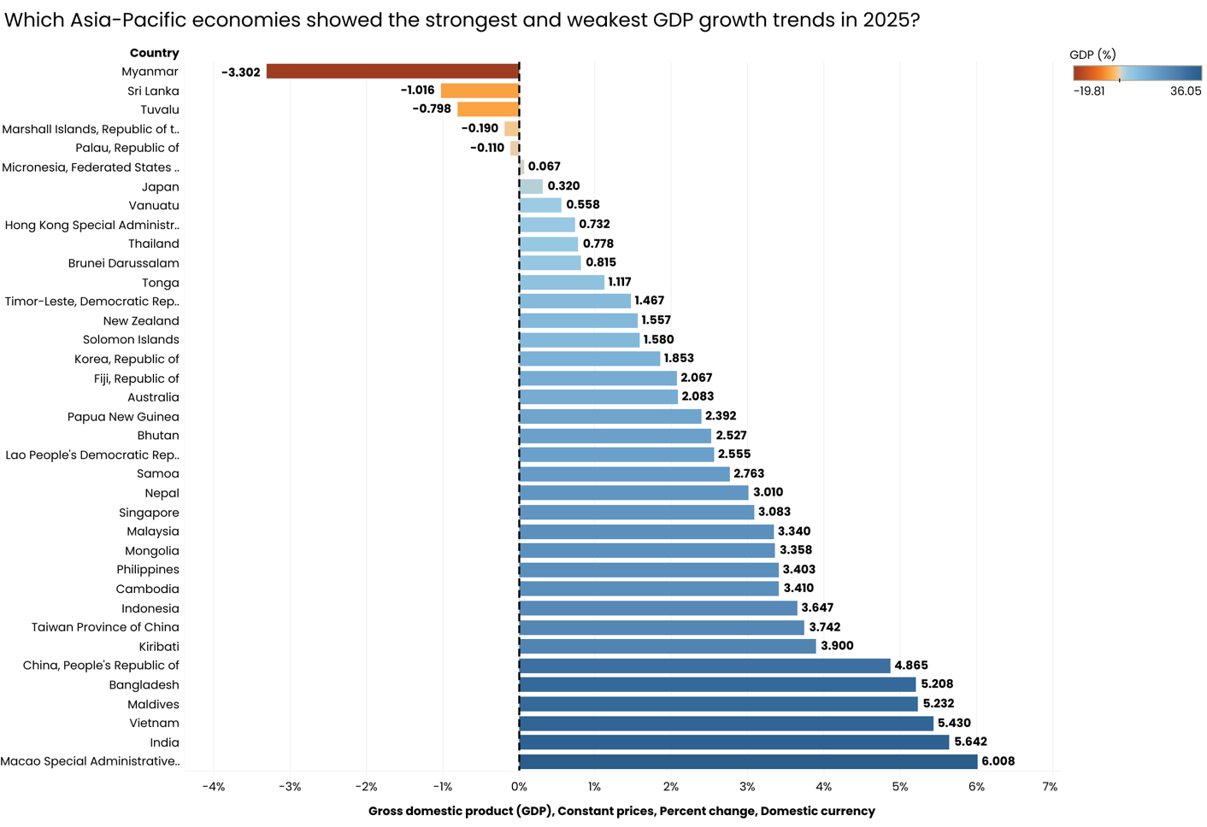

## 2020-2025 (Only largest 5 economies will be used for data viz - China, Japan, India, Australia, Korea)
SELECT *
FROM data_original_staging_2
WHERE INDICATOR = 'Gross domestic product (GDP), Constant prices, Percent change, Domestic currency'
AND TIME_PERIOD BETWEEN 2020 And 2025
;
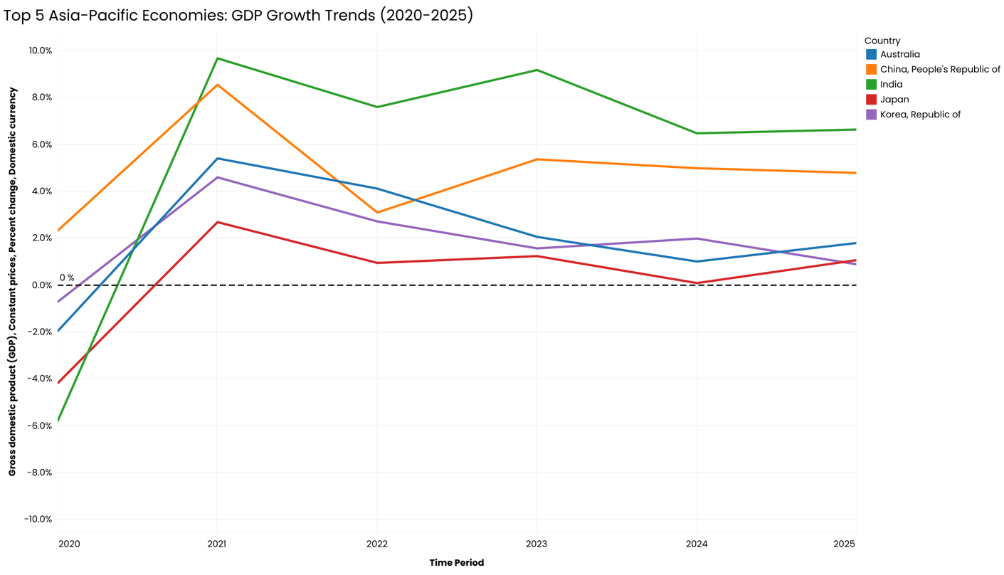

## How do investment and saving trends vary across countries?

##2025
SELECT *
FROM data_original_staging_2
WHERE INDICATOR = 'Current account balance (credit less debit), Percent of GDP in US dollars'
AND TIME_PERIOD = 2025
;
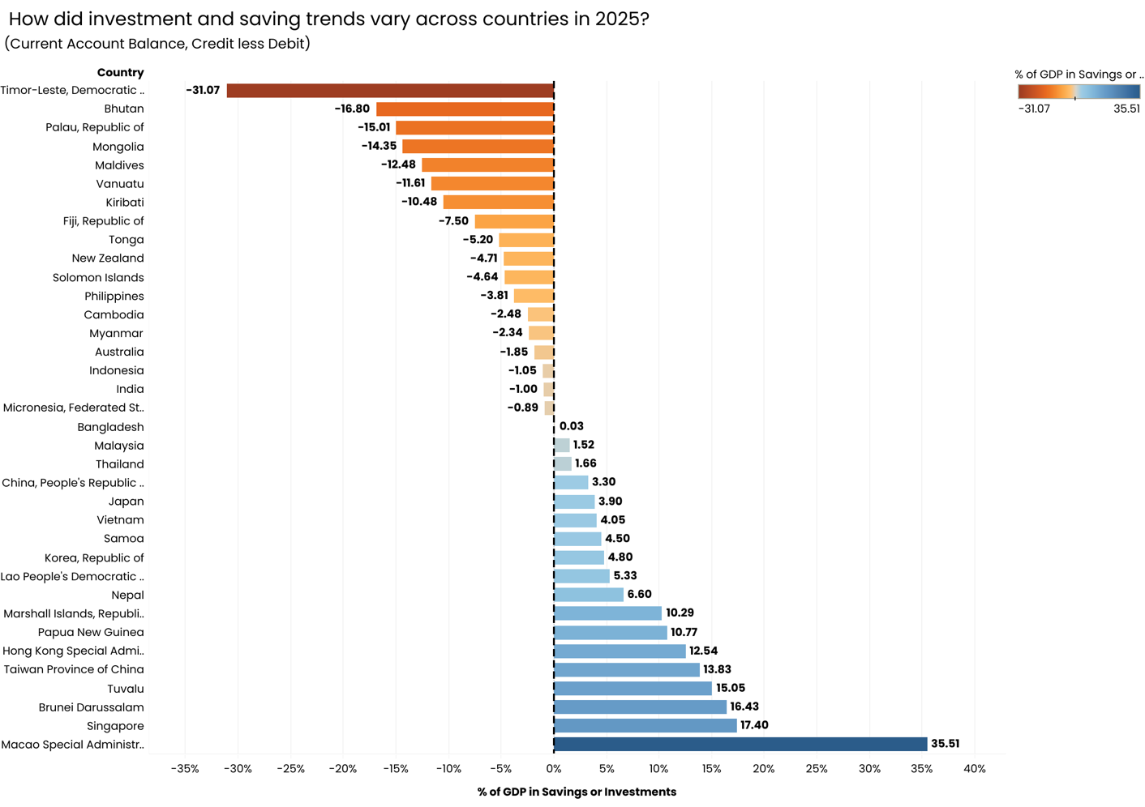

## 2020-2025 (Only largest 5 economies will be used for data viz - China, Japan, India, Australia, Korea)
SELECT *
FROM data_original_staging_2
WHERE INDICATOR = 'Current account balance (credit less debit), Percent of GDP in US dollars'
;
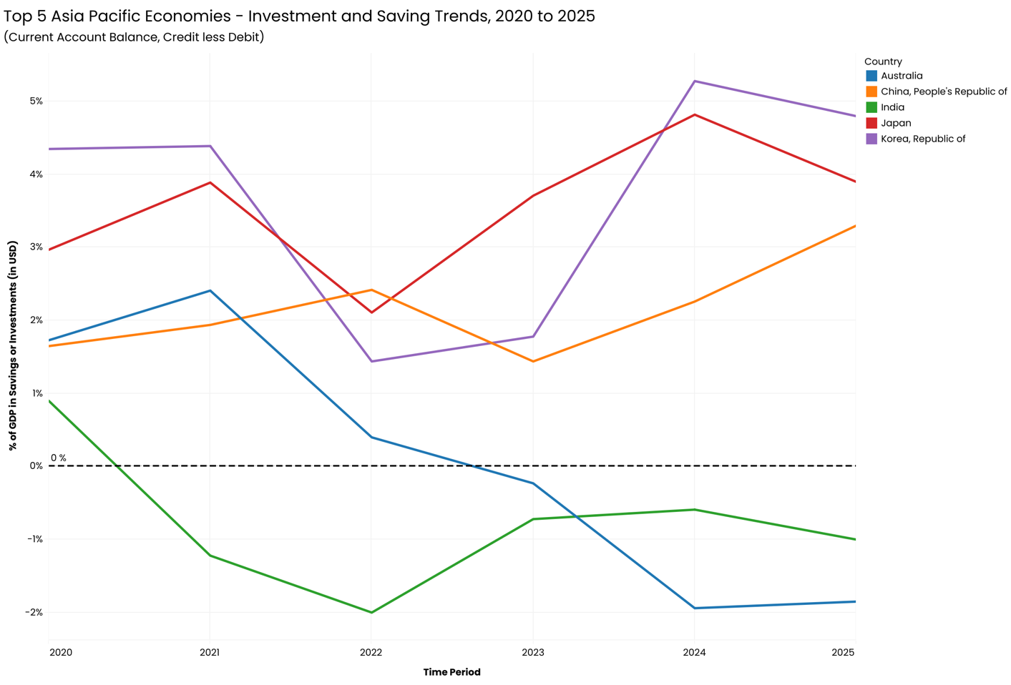

## Which economies appear most stable vs volatile over time?

##2025
SELECT *
FROM data_original_staging_2
WHERE INDICATOR IN (
'Unemployment rate',
'All Items, Consumer price index (CPI), Period average, percent change',
'Gross domestic product (GDP), Constant prices, Percent change, Domestic currency'
)
AND TIME_PERIOD = 2025;

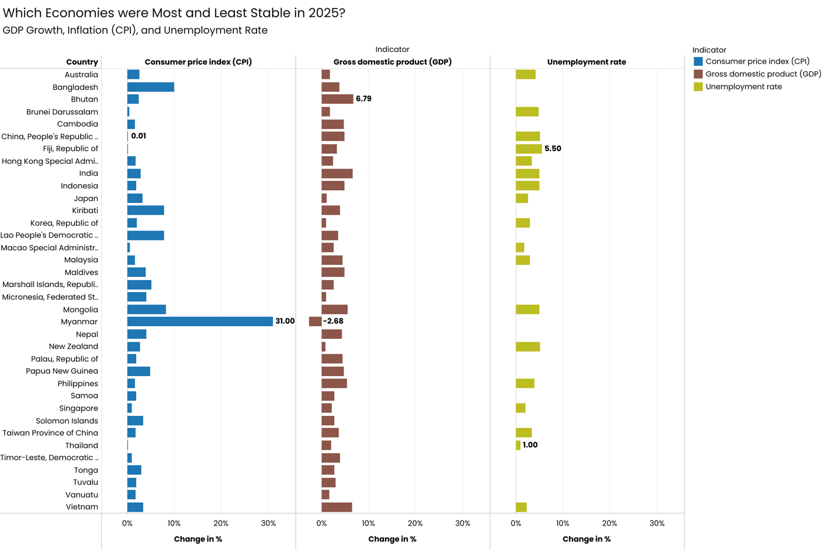

## 2020-2025 (Only largest 5 economies will be used for data viz - China, Japan, India, Australia, Korea) 3 different data vizz as there are 3 indicators over 5 years
SELECT *
FROM data_original_staging_2
WHERE INDICATOR IN (
'Unemployment rate',
'All Items, Consumer price index (CPI), Period average, percent change',
'Gross domestic product (GDP), Constant prices, Percent change, Domestic currency'
)
;
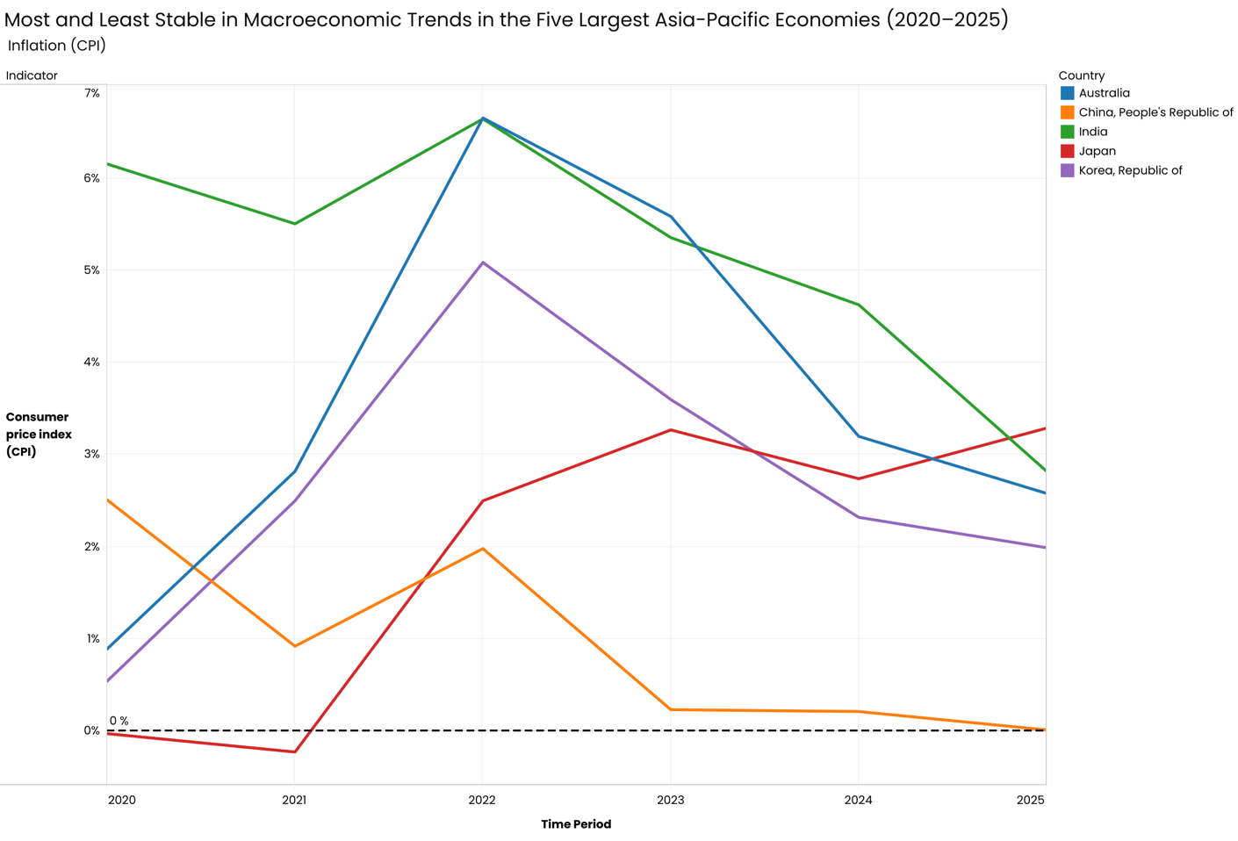

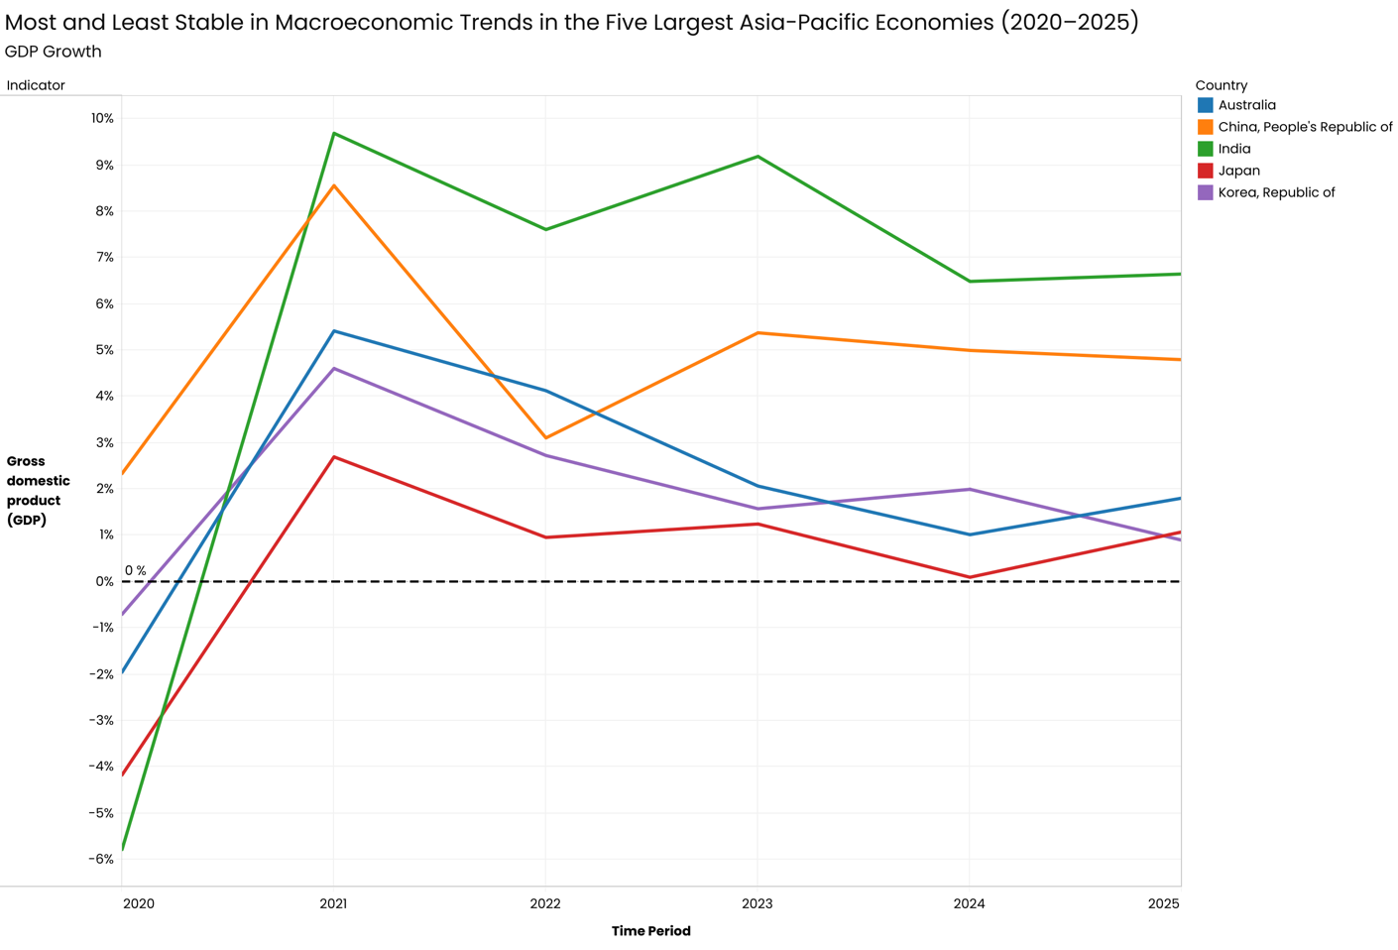

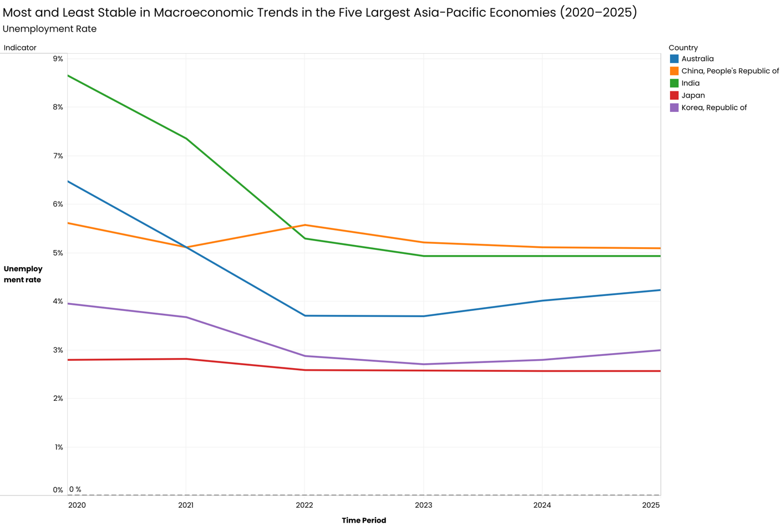

## Are high growth economies also experiencing higher inflation?
## Compare average GDP growth vs average inflation by country (or year-by-year correlation).

## 2025
SELECT COUNTRY,
AVG(CASE
WHEN INDICATOR = 'Gross domestic product (GDP), Constant prices, Percent change, Domestic currency'
THEN OBS_VALUE
END) AS avg_gdp_growth,
AVG(CASE
WHEN INDICATOR = 'All Items, Consumer price index (CPI), Period average, percent change'
THEN OBS_VALUE
END) AS avg_inflation
FROM data_original_staging_2
WHERE TIME_PERIOD = 2025
GROUP BY COUNTRY
;

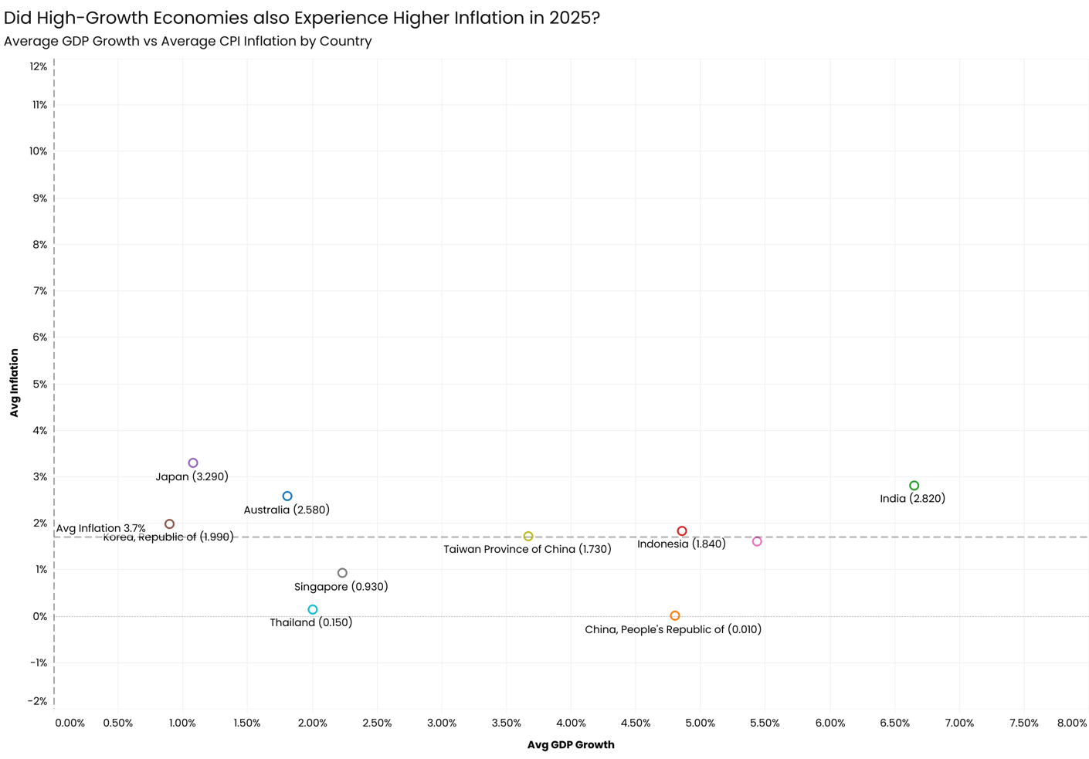

## 2020-2025 (Only largest 5 economies will be used for data viz - China, Japan, India, Australia, Korea)
SELECT COUNTRY,
AVG(CASE
WHEN INDICATOR = 'Gross domestic product (GDP), Constant prices, Percent change, Domestic currency'
THEN OBS_VALUE
END) AS avg_gdp_growth,
AVG(CASE
WHEN INDICATOR = 'All Items, Consumer price index (CPI), Period average, percent change'
THEN OBS_VALUE
END) AS avg_inflation
FROM data_original_staging_2
WHERE TIME_PERIOD BETWEEN 2020 AND 2025
GROUP BY COUNTRY
;

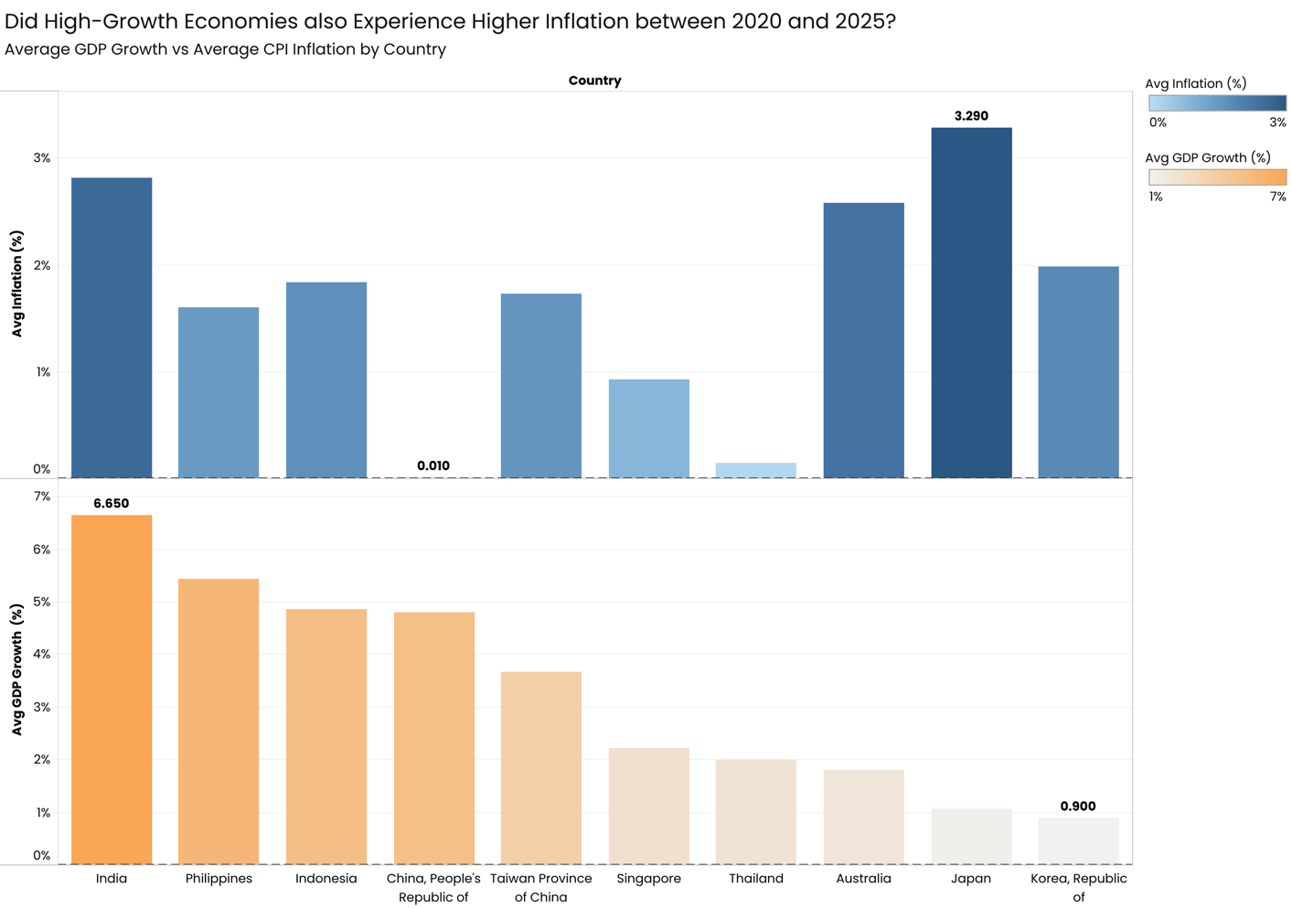

## Which economies show consistent growth?
## “Consistency” = low volatility + positive average growth

SELECT COUNTRY,
AVG(OBS_VALUE) AS avg_gdp_growth,
MAX(OBS_VALUE) - MIN(OBS_VALUE) AS gdp_growth_range
FROM data_original_staging_2
WHERE INDICATOR = 'Gross domestic product (GDP), Constant prices, Percent change, Domestic currency'
AND TIME_PERIOD BETWEEN 2020 AND 2025
GROUP BY COUNTRY
;

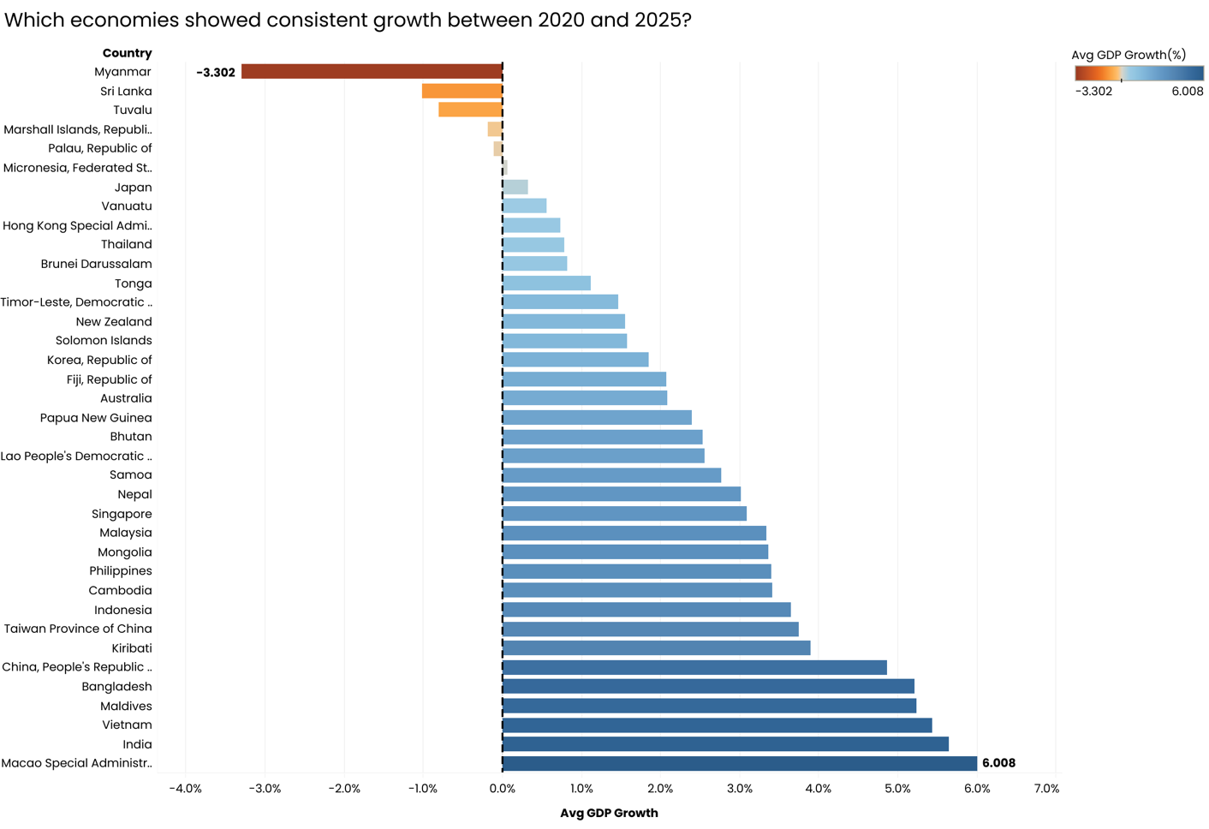

## Which economies are structurally dependent on foreign capital?
## Persistent negative current account balance = reliance on foreign capital

##2025
SELECT COUNTRY,
AVG(OBS_VALUE) AS avg_current_account_balance
FROM data_original_staging_2
WHERE INDICATOR = 'Current account balance (credit less debit), Percent of GDP in US dollars'
AND TIME_PERIOD = 2025
GROUP BY COUNTRY
;

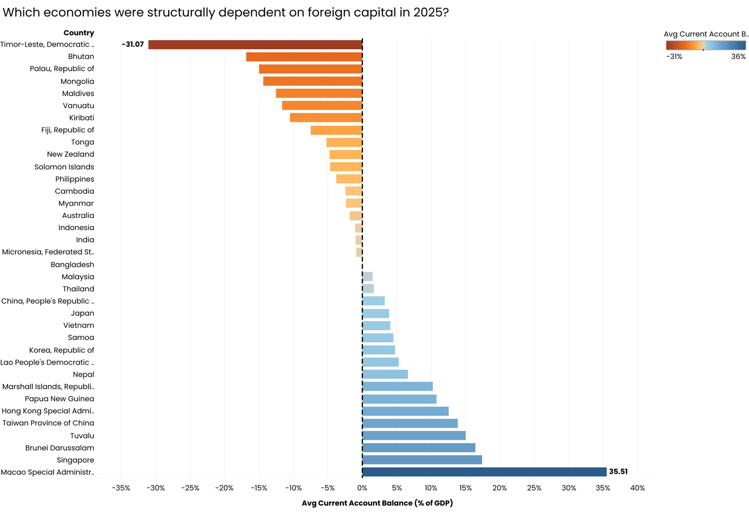

## Who performs best on a low inflation + low unemployment metric?
## Lowest average inflation, Lowest average unemployment

## 2020-2025
SELECT COUNTRY,
AVG(CASE
WHEN INDICATOR = 'All Items, Consumer price index (CPI), Period average, percent change'
THEN OBS_VALUE
END) AS avg_inflation,
COALESCE(AVG(CASE
WHEN INDICATOR = 'Unemployment rate'
THEN OBS_VALUE END), 0) AS avg_unemployment -- Replaces NULL avg result with 0
FROM data_original_staging_2
WHERE TIME_PERIOD BETWEEN 2020 AND 2025
GROUP BY COUNTRY
ORDER BY avg_inflation ASC, avg_unemployment ASC
;
